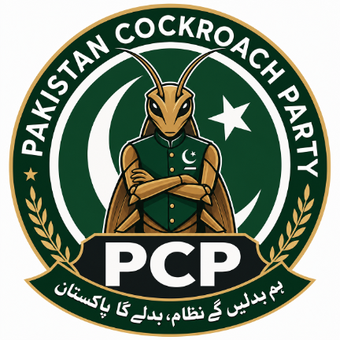
A GEN Z-INITIATED, PEACEFUL & CONSTITUTIONAL REFORM MOVEMENT
PAKISTAN
COCKROACH PARTY
MANIFESTO
We Will Change the System, Pakistan Will Change
SHORT FORM · JULY 2026 · SHARE THIS ONE

THE CHANT
Every few months, someone announces relief. The price drops for a season. The bill gets a subsidy. Then it comes back — worse.
That's not bad luck. That's a system with no memory and no consequences.
Nobody loses their job when the exam paper leaks. Nobody loses their post when the load-shedding schedule doesn't add up. So we're not asking for another relief package. We're asking why the same failure keeps getting a new name.
PCP | We Will Change the System, Pakistan Will Change

WHO WE ARE

Not a personality. A discipline.
Pakistan doesn't need another face. It needs a system that works the same way for everyone, whether or not you know someone. PCP is a Gen Z-initiated but all-Pakistani, peaceful, constitutional reform movement — open to every Pakistani, of every age, who's done watching the same failure get a new name every election cycle.
Our loyalty is only to Pakistan, its Constitution and its people. Nothing else — not a founder, not a donor, not a party.

Why the cockroach?
They've called this generation lazy, entitled, obsessed with leaving. Fine. Here's what's true instead: we grew up doing homework by candlelight during load-shedding, learned new skills from a phone with two bars of signal, and are still here — still applying, still building, still arguing for a better Pakistan instead of just booking the visa appointment.
You can step on a cockroach and it gets up. That's the joke. It's also not a joke.
It's not an insult we're using — it's one we took back. So we're strict about it: PCP members never call opponents, officials or ordinary citizens "cockroaches" or "filth." The symbol is ours, aimed at ourselves, and it means one thing only:
- Survival — staying active and hopeful through crisis after crisis.
- Adaptability — learning new skills and better ways of organising, fast.
- Persistence — refusing to accept injustice as just "how things are."
- Self-accountability — cleaning our own house before we criticise anyone else's.

WHAT WE ACTUALLY WANT

Five demands. Not five promises.
Every demand below comes with a costed policy paper, a 100-day plan and numbers we publish so you can check whether we kept our word. This page has the headline. The full detail is in the Movement Manual.
01 One Law, One Accountability — Same rules for a minister's son and a mechanic's son. Asset declarations, open contracts, courts that publish how long a case actually takes.
02 Lower Inflation, Higher Income — Not another price freeze — fair tax enforcement, a minimum wage that moves with real prices, and public data on where the money actually goes.
03 Work or a Way to Build Something — Government can't hire everyone. It can stop making it impossible to start a business, get an apprenticeship, or get paid what a job is actually worth.
04 Show Us the Bill Before You Send Us the Bill — Full public numbers on what electricity actually costs to generate, where it leaks, and who's protected from the real price — before another bill lands.
05 Every Child in School, Every Skill Worth Something — Not enrolment photos — attendance, literacy you can measure, teachers who show up, and a path from school into real work.

THE RULES WE HOLD OURSELVES TO

Ten lines we don't cross.
01 Same law for everyone — Family, wealth or connection doesn't change the standard of justice.
02 Best person for the job — Appointments and contracts go by published criteria — not who you know.
03 Show your work — Budgets, contracts and decisions in formats a normal person can actually search.
04 An economy that hires — Tax and trade policy judged by one thing: does it create real, dignified work.
05 Skills that are worth something — Every child in school. Every young person with a skill someone will pay for.
06 Show us the bill first — A transparent account of what energy actually costs, before we're charged for it.
07 Every office has a leash — Defined powers, a term limit, and a real way to appeal a decision — including ours.
08 Decisions made close to home — Water, roads and local services decided by the people who live with them.
09 Disagreement isn't enmity — We criticise with evidence and law — never hatred, threats or violence.
10 Constitution above everyone — Every reform follows the law. No exceptions for anyone, including us.

JOIN

This isn't a fan club. It's a pledge.
"I pledge loyalty to Pakistan, its Constitution and its people. I will act peacefully, lawfully and honestly — reject hatred and misinformation, disclose conflicts of interest, and accept fair accountability. I will work to change systems through knowledge, service and democratic participation."
If that's a pledge you'd actually sign — not just repost — you're already one of us. Bring a friend who's about to give up on this country and show them this page instead.
ہم بدلیں گے پاکستان
WE WILL CHANGE THE SYSTEM, PAKISTAN WILL CHANGE
@pakistancockroach · Draft 1.0, issued for public consultation — read the full Movement Manual for governance, finance and how to start a chapter.

